

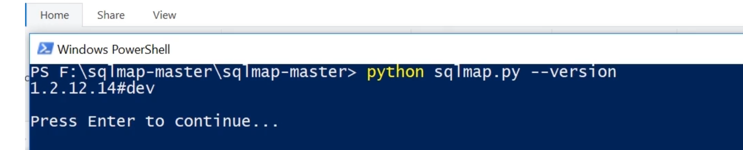

SQLMap Switches: <https://github.com/sqlmapproject/sqlmap/wiki/Usage>

